**A PROJECT REPORT ON**

**GSM BASED REMOTE MONITORING AND BILLING**

**SUBMITED BY**

**AWESOME**

**Aditya M Anand (NEC0912001)**

**Athun VM (NEC0912016)**

**Gayathri M (NEC0912027)**

**Jeevanandam (NEC0912031)**

**Jishnunand PK (NEC0912032)**

**Manoj S Mali (NEC0912037)**

**JUNE 2015**

**Submitted in the particular fulfillment of requirements for the award of Diploma in Information Technology**

**NETTUR TECHNICAL TRAINING FOUNDATION**

**#40/40 A, IT BLOCK, Electronic City,**

**Hosur Road**

**Bangalore - 560100**

**NETTUR TECHNICAL TRAINING FOUNDATION**

**#40/40 A, IT BLOCK, Electronic City,**

**Hosur Road**

**Bangalore – 560100**

**CERTIFICATE**

**This to certify that the project work titled “SOUTHERN POWER DISTRIBUTION COMPANY” Has been successfully completed in fulfillment of the award of Diploma in Information Technology Offered by NTTF during the academic year 2015**

**Project Guide Academic In charge Principal**

**Examiners**

**Name of the Examiners Signature with Date**

**SYNOPSIS**

**The idea of the developing the application is to provide support for the new post-paid meters, managed remotely by SMS base on GSM.**

**This application also provides a facility for the customers like online bill payment.**

**It is particularly applicable for developing and underdeveloped countries where such a post-payment solution may be desirable.**

**It can solve all the standard business problems existing in operation and maintenance of utilities that use a post payment system.**

**ACKNOWLEDGEMENT**

We express our sincere gratitude to **Mrs.Prabha, Mr.Sreedhar** our project in charge for providing us with such a great facility and good staff to improve our skills. The intensive training to us useful and we learnt most of the IDE’S.

We are grate full to **Mrs.Chitra** **Devi** and **Mr.Jagadish** for their unwavering support and active cooperation throughout the project work.

Finally a round of thanks to the team of NTTF IT CENTER, the teaching and non-teaching staff for their help extended to us. Last but not the least we would acknowledge and abundant help received from our friends in successful completion of our project

**CONTENTS**

1. **Introduction**

* 1. Title Of The Project
  2. Group Name
  3. Group Leader
  4. Group Members
  5. S/W & H/W Configuration
  6. Technology Used
  7. Project Description
  8. Project Modules
  9. Project Plan

1. **SRS Document**
2. **System Design**
   1. Controll flow diagram
   2. Data Flow Diagram
   3. Entity Relationship Diagram
   4. Use case Diagram
   5. Database Design
   6. Data Dictionary
   7. Gantt chart
3. **Snapshots**
4. **Source Code**
5. **Reports**
   1. Test Plan
   2. Test Case
   3. Bug Report
6. **Future enhancement of project**
7. **Bibliography**
8. **Conclusion**
   1. TITLE OF THE PROJECT

SOUTHERN POWER DISTRIBUTION COMPANY………………….

* 1. GROUP NAME

AWESOME…………..

* 1. GROUP LEADER

Aditya M Anand -(NEC0912001)

* 1. GROUP MEMBERS

Athun VM (NEC0912016)

Gayathri M (NEC0912027)

Jeevanandam (NEC0912031)

Jishnunand PK (NEC0912032)

Manoj S Mali (NEC0912037)

* 1. S/W & H/W CONFIGURAION

SOFWARE REQUIREMENT

Front End 🡪 JSP, HTML, CSS

Database 🡪 Oracle10g

Scripting language 🡪 Jquery, Bootsrap

Web Server 🡪 Apache Tomcat Server6.0

Operating System 🡪 Windows 7 and higher version

IDE 🡪 Eclipse with my Eclipse plug ins,

Sublime text3

Third Party Software 🡪 Ozeking SMS Gateway

Social Services 🡪 Gmail Services for sending mail

Browsers 🡪 IE8/8+, Chrome15+, Safari 4+, Mozilla Firefox

HARDWARE REQUIREMENT

Processor : Pentium IV

Hard disk : 80GB

Ram : 512MB

* 1. PROJECT DESCRIPTION

The objective of this project is to replace the existing manual reading of electricity meters installed throughout the country (Home, Agricultural, and Industrial).

The proposed solution is to build a server for the Electricity boards in each state where the custom built GSM meters would update in real time through SMS.

* 1. PROJECT MODULES

Admin

LOGIN

CREATE/DELETE USER

MAINTAINING GSM DEVICE

GENERATE BILLS

SEND SMS TO CLIENTS

SIGNALS TO DEVICE

SEND AKNOWLEDGEMENT TO USERS

VIEW CLIENT QUERIES

SEND RESPONSE TO CLIENT QUERIES

PAYMENT

LOG OUT

User:

LOGIN

VIEW BILLS

CUSTOMER DETAILS

PAYMENT

FEEDBACK/COMPLAINTS

LOG OUT

* 1. PROJECT PLAN

Requirement Analysis

Design and Coding

Testing

Implemention

1. SOFTWARE REQUIREMENT SPECIFICATION

The aim of proposed system is to develop a system of improved facilities. The proposed system can overcome all the limitations of the existing system.

Advantages:

1. It provides an advantage and support the concept of e-governance

in the electric reading and metering.

1. Our system provides the customer precise consumption information.
2. It gives accurate billings.
3. Provides better and fast customer service. It reduces man power and time consumption.

USE CASE DIAGRAM :

USER DIAGRAM: 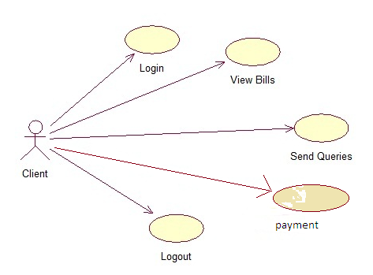

ADMIN USE CASE DIAGRAM: 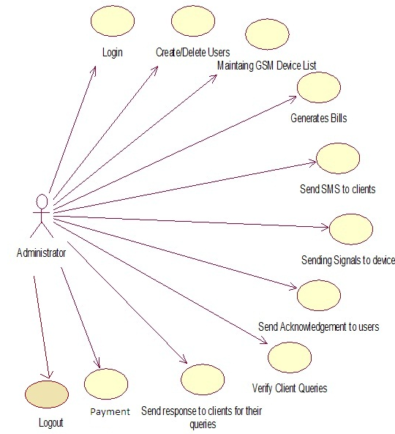

3.1 CFD

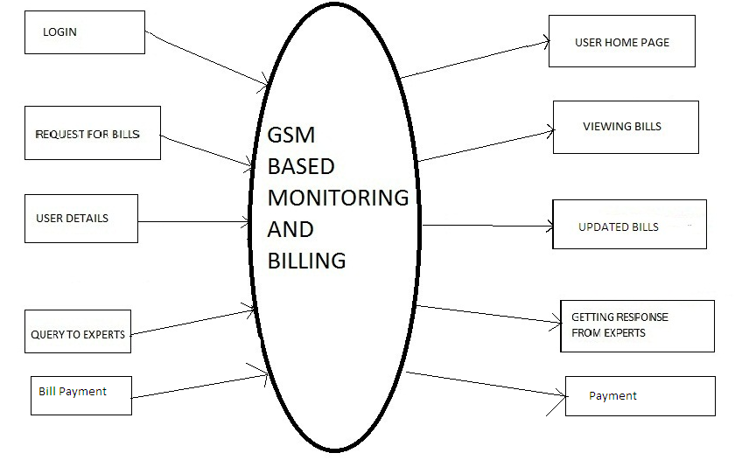USER FUNCTIONALITY

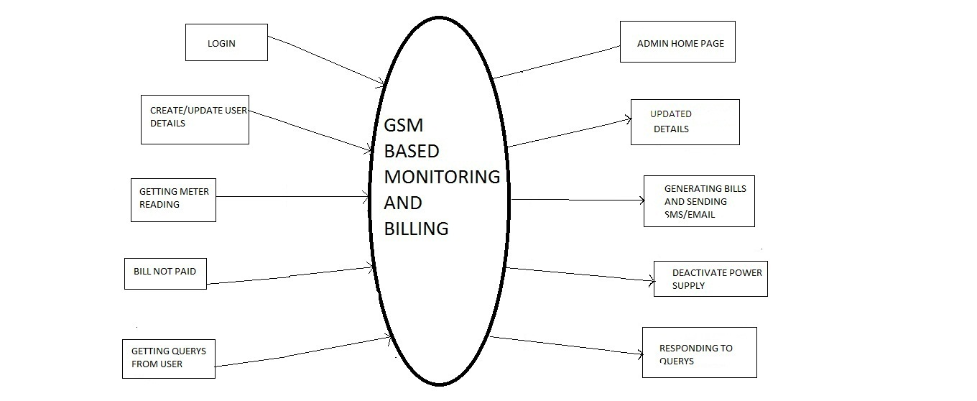ADMIN FUNCTIONALITY

ADMFUNCTIONALITY

3.2 DFD

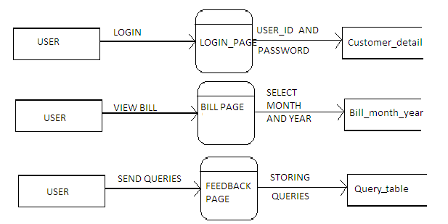

DFD cont..

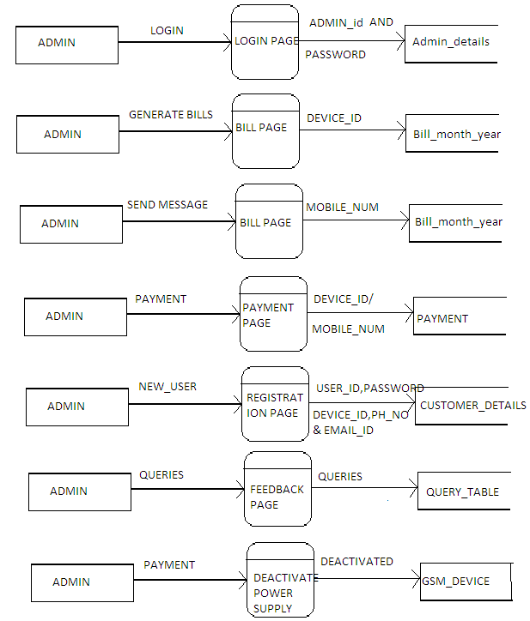

ER DIAGRAM

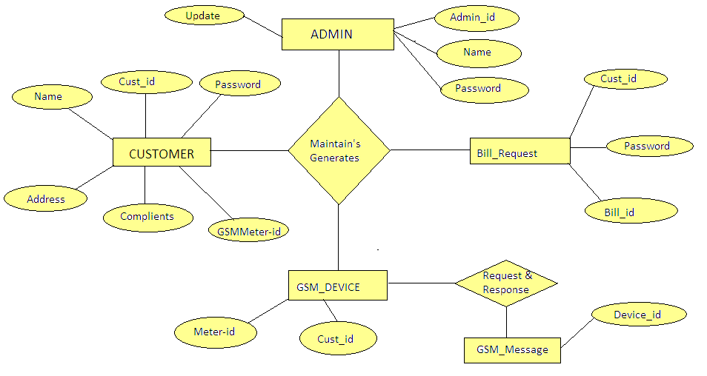

GANTT CHART

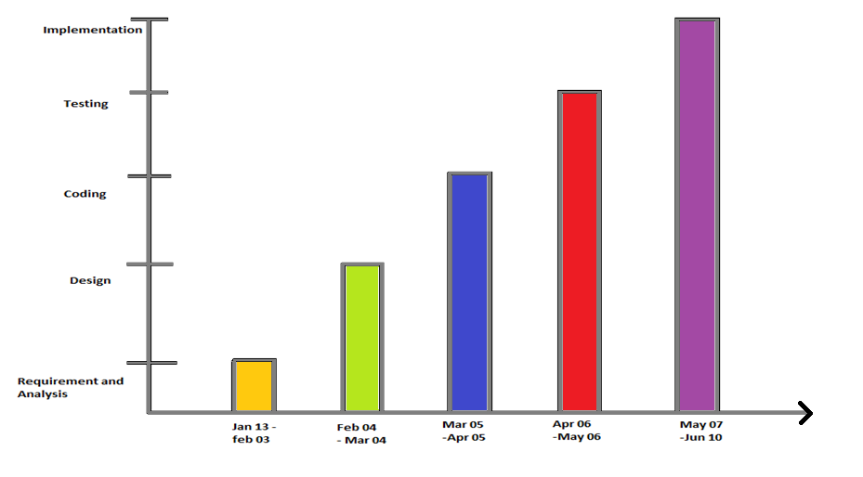

CONCLUSION

By doing this project we have learned how to execute a real time project. After doing this project we got much better knowledge. This project completion taught us the importance of Team work.

We are very grateful being able to pursue this project which could not be done without the help of our kind and helpful staffs.